Project Development Phase I
Project Flow
To accomplish this, we have to complete all the activities listed below,
Data Collection & Extraction from Database
o Collect the dataset,
o Storing Data in DB
o Perform SQL Operations
o Connect DB with Tableau Data Preparation
o Prepare the Data for Visualization
Data Visualizations
o Number of Unique Visualizations
Dashboard
o Responsive and Design of Dashboard
Story
o No of Scenes of Story
Data Collection & Extraction from Database
Data collection is the process of gathering and measuring information on variables of interest, in an established systematic fashion that enables one to answer stated research questions, test hypotheses, and evaluate outcomes and generate insights from the data
Toy Manufacturers in US States | Kaggle.
Toy Manufacturer Data by State and Year.
Reference link : https://www.kaggle.com/datasets/thedevastator/toy-manufacturers-in-us-states?select=Week+39+-+US+Toy+Manufacturers+-+2005+to+2016.hyper
understand the data
Data contains all the meta information regarding the columns described in the CSV files. we have provided 1 CSV files:
1. Week 39 - US Toy Manufacturers - 2005 to 2016
Column Description for Week 39 - US Toy Manufacturers - 2005 to 2016
- State: The state where the toy manufacturers are located. (Categorical)
- Year: The year during which data was recorded. (Numeric)
- Number of Manufacturers: The total number of toy manufacturers in a specific state and year. (Numeric)
- Index: Number of toy manufacturer
- Week 39 - US Toy Manufacturers - 2005 to 2016
- Storing Data in DB & Perform SQL Operations
No of Unique Visualizations(8 visualizations)
The number of unique visualizations that can be created with a given dataset. Some common types of visualizations that can be used to analyze the performance and efficiency of ToyCraft Tales: Tableau's Vision into Toy Manufacturer Data include bar charts, line charts, heat maps, scatter plots, pie charts, Maps, etc. These visualizations can be used to compare performance, track changes over time, show distribution, and relationships between variables, breakdown of revenue and customer demographics, workload, resource allocation, and location of hotels.

- Analysis on number of Manufacturer by Year

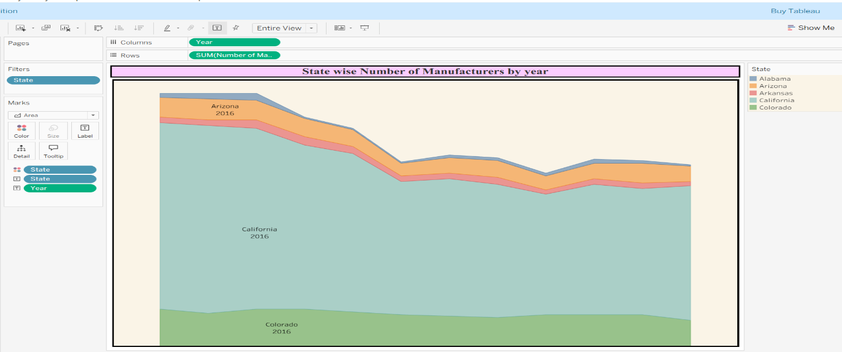
- Analysis on Toy Manufacturer by index
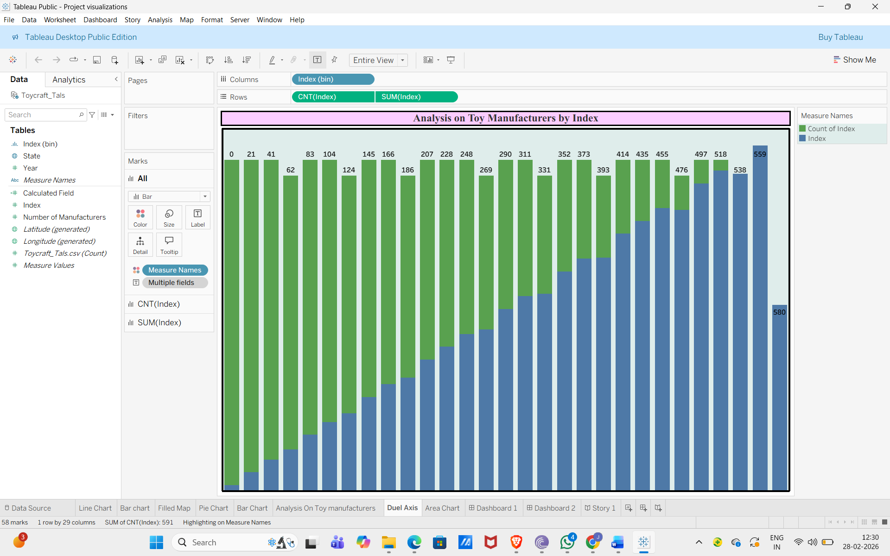
- Analysis on toy Manufacturer in US state By Index
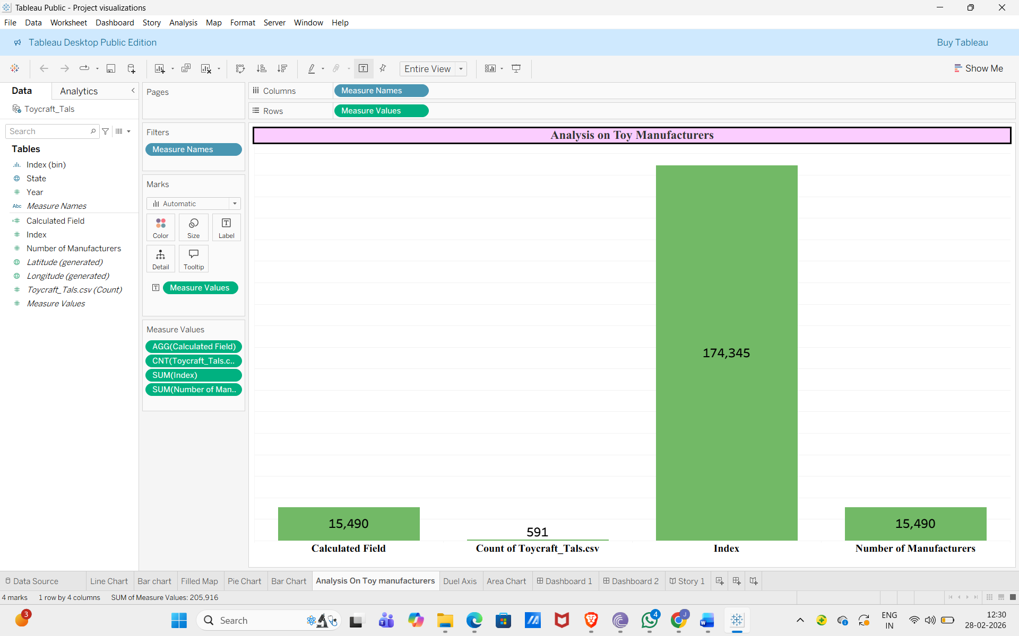
- Top 10 states toy manufacturer in US state
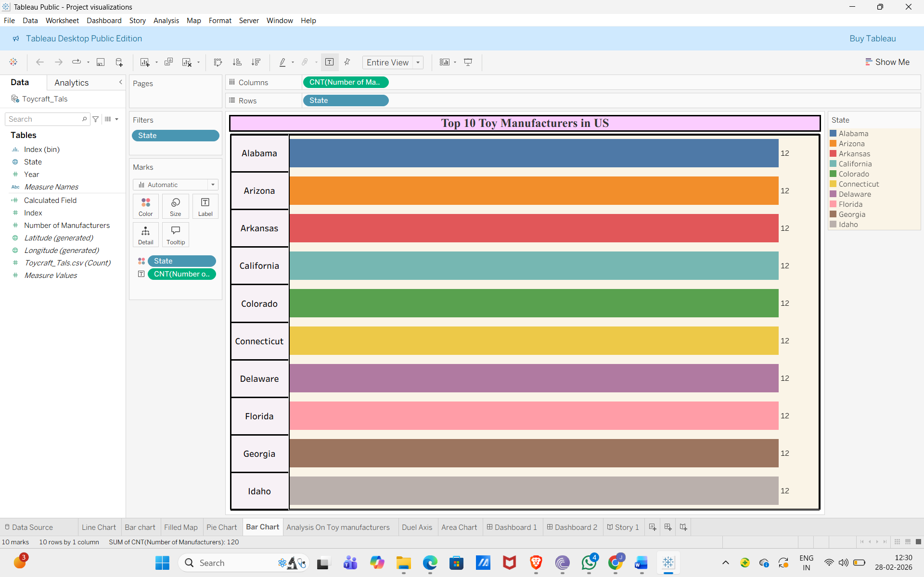
- Manufacturer Growth by Year
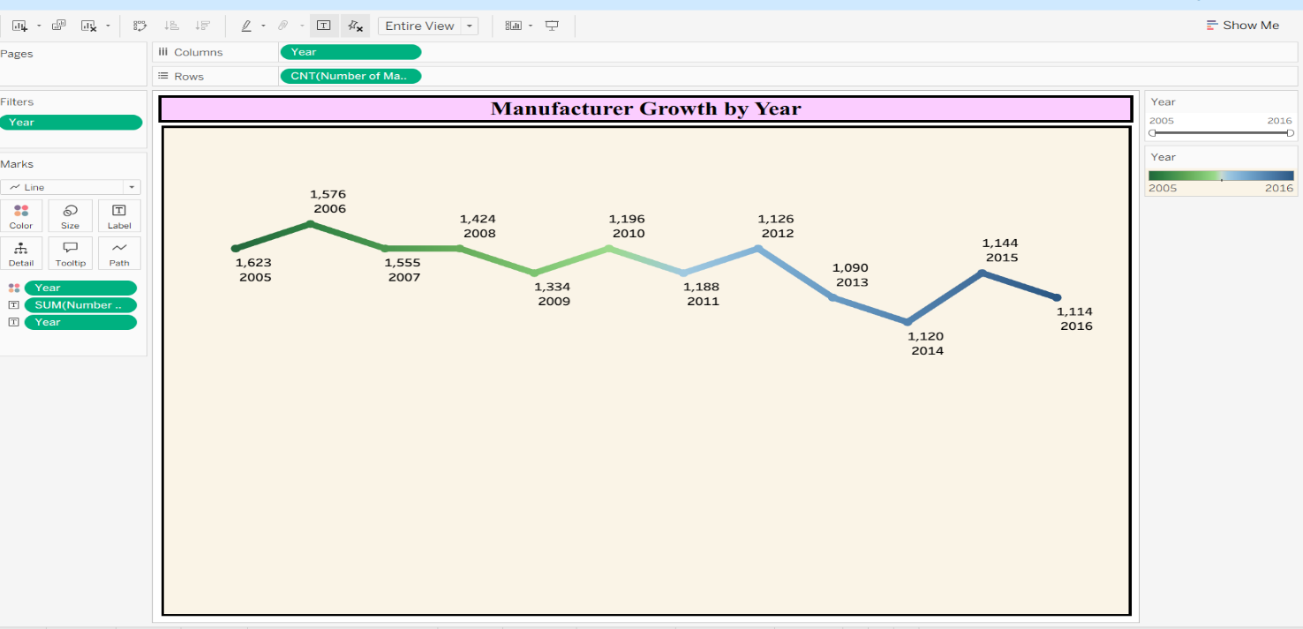

- Top 10 States by Index
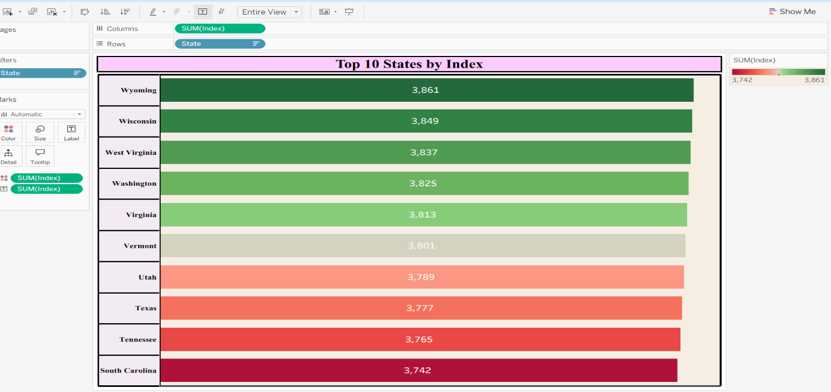
- State Wise Index
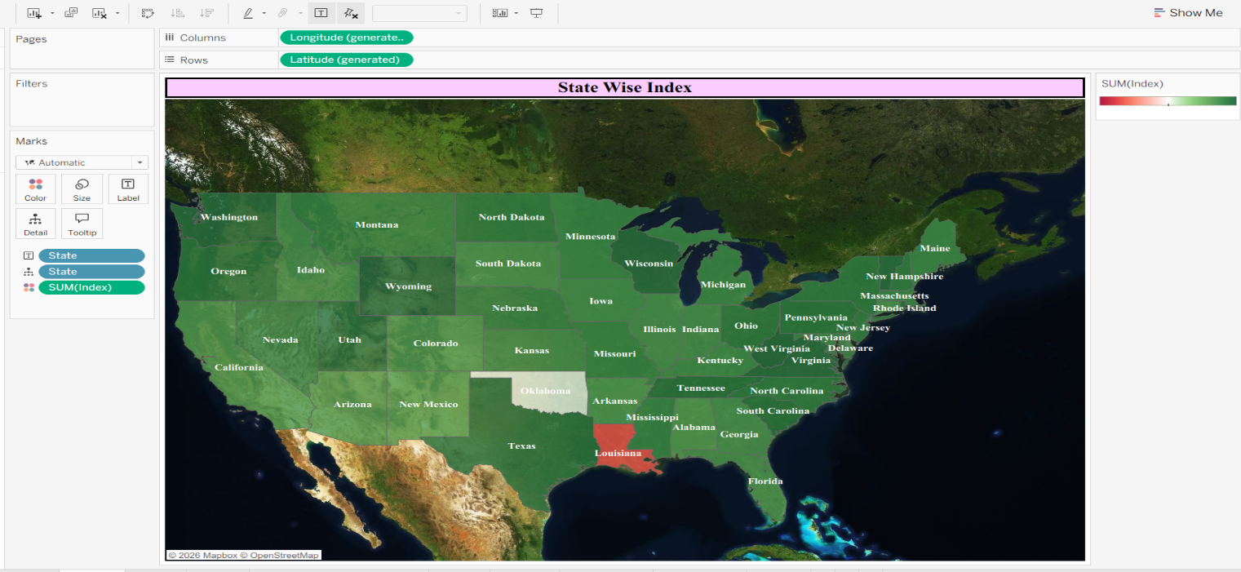
- Manufacturer Distribution
